Ryan Miller

### **Mission 1**

**Issue**: Due to the DoS attack, the Empire took down the Resistance's DNS and primary email servers.

* The Resistance's network team was able to build and deploy a new DNS server and mail server.
* The new primary mail server is asltx.l.google.com and the secondary should be asltx.2.google.com.
* The Resistance (starwars.com) is able to send emails but is unable to receive any.

Your mission:

* Determine and document the mail servers for starwars.com using NSLOOKUP.
* Explain why the Resistance isn't receiving any emails.
* Document what a corrected DNS record should be.

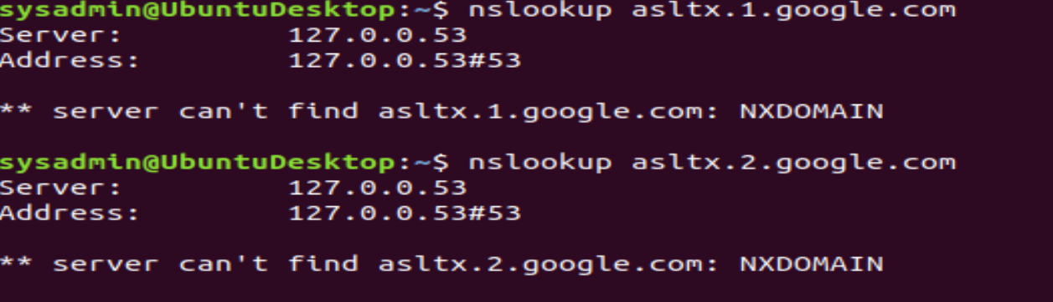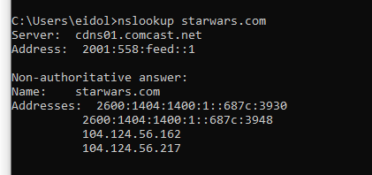

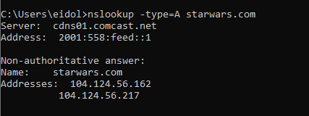

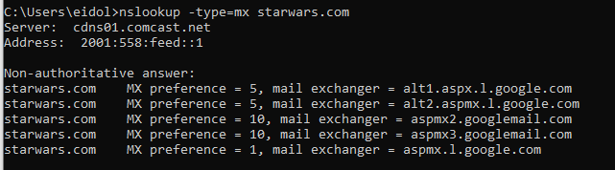

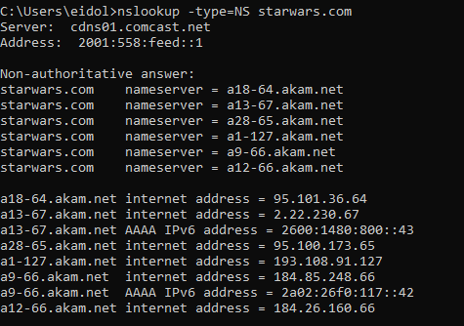

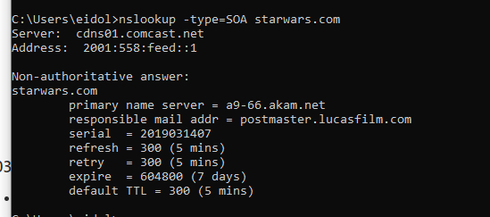

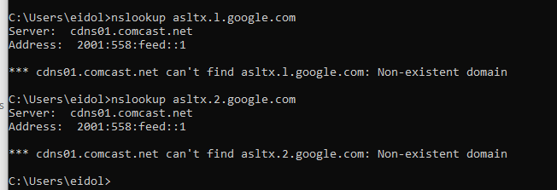

MX shows that the mail servers are listed differently than what is intended.

aspmx.1.google.com should be changed to as1tx.google.com

### **Mission 2**

**Issue**: Now that you've addressed the mail servers, all emails are coming through. However, users are still reporting that they haven't received mail from the theforce.net alert bulletins.

* Many of the alert bulletins are being blocked or going into spam folders.
* This is probably due to the fact that theforce.net changed the IP address of their mail server to 45.23.176.21 while your network was down.
* These alerts are critical to identify pending attacks from the Empire.

Your mission:

* Determine and document the SPF for theforce.net using NSLOOKUP.
* Explain why the Force's emails are going to spam.
* Document what a corrected DNS record should be.

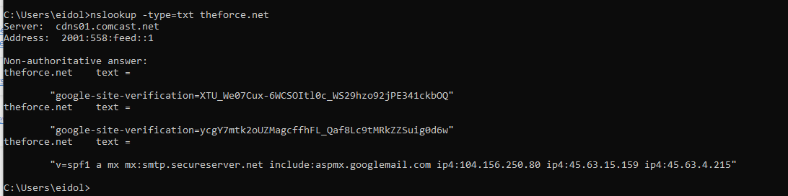

The IP is not in the list of IP addresses of mail servers allowed to send emails on its behalf.

### **Mission 3**

**Issue**: You have successfully resolved all email issues and the resistance can now receive alert bulletins. However, the Resistance is unable to easily read the details of alert bulletins online.

* They are supposed to be automatically redirected from their sub page of resistance.theforce.net to theforce.net.

Your mission:

* Document how a CNAME should look by viewing the CNAME of www.theforce.net using NSLOOKUP.
* Explain why the sub page of resistance.theforce.net isn't redirecting to www.theforce.net.
* Document what a corrected DNS record should be.

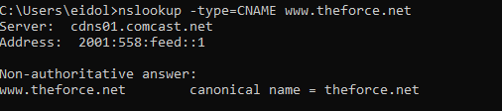

The subpage is not a canonical name of [www.theforce.net](http://www.theforce.net)

A canonical name of resistance.theforce.net should be added

### **Mission 4**

**Issue**: During the attack, it was determined that the Empire also took down the primary DNS server of princessleia.site.

* Fortunately, the DNS server for princessleia.site is backed up and functioning.
* However, the Resistance was unable to access this important site during the attacks and now they need you to prevent this from happening again.
* The Resistance's networking team provided you with a backup DNS server of: ns2.galaxybackup.com.

Your mission:

* Confirm the DNS records for princessleia.site.
* Document how you would fix the DNS record to prevent this issue from happening again.

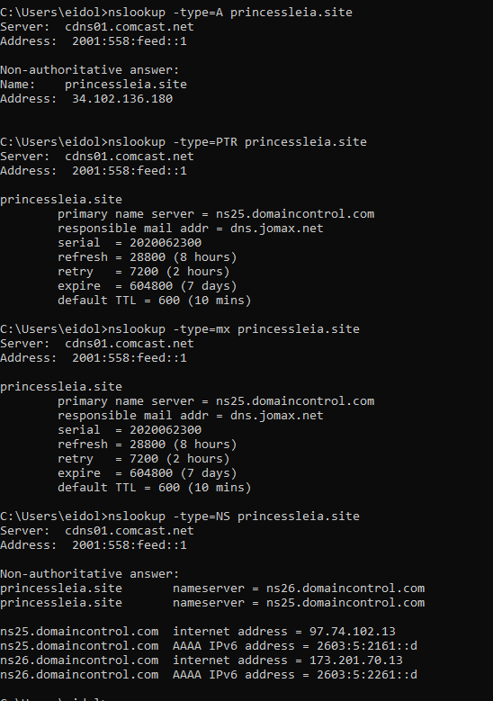

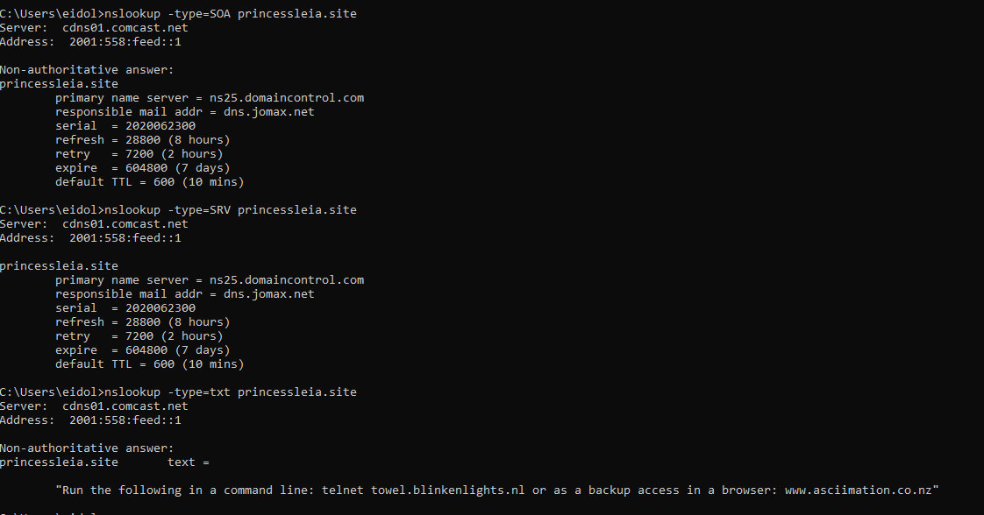

Having more than one MX record as a backup in case one isn't available, or to provide load balancing for large volumes of emails

### **Mission 5**

**Issue**: The network traffic from the planet of Batuu to the planet of Jedha is very slow.

* You have been provided a network map with a list of planets connected between Batuu and Jedha.
* It has been determined that the slowness is due to the Empire attacking Planet N.

Your Mission:

* View the Galaxy Network Map and determine the OSPF shortest path from Batuu to Jedha.
* Confirm your path doesn't include Planet N in its route.
* Document this shortest path so it can be used by the Resistance to develop a static route to improve the traffic.

Shortest Path without N:

Batuu-D-C-E-F-J-I-L-Q-T-V-Jedha

Shortest Path:

Battu-D-C-E-F-J-K-N-O-R-Q-T-V-Jedha

1+2+1+1+1+2+1+2+1+2+2+2+2 = 20

### **Mission 6**

**Issue:** Due to all these attacks, the Resistance is determined to seek revenge for the damage the Empire has caused.

* You are tasked with gathering secret information from the Dark Side network servers that can be used to launch network attacks against the Empire.
* You have captured some of the Dark Side's encrypted wireless internet traffic in the following pcap: Darkside.pcap.

Your Mission:

* Figure out the Dark Side's secret wireless key by using Aircrack-ng.  
  + Hint: This is a more challenging encrypted wireless traffic using WPA.
  + In order to decrypt, you will need to use a wordlist (-w) such as rockyou.txt.
* Use the Dark Side's key to decrypt the wireless traffic in Wireshark.  
  + Hint: The format for the key to decrypt wireless is <Wireless_key>:<SSID>.
* Once you have decrypted the traffic, figure out the following Dark Side information:  
  + Host IP Addresses and MAC Addresses by looking at the decrypted ARP traffic.
  + Document these IP and MAC Addresses, as the resistance will use these IP addresses to launch a retaliatory attack.

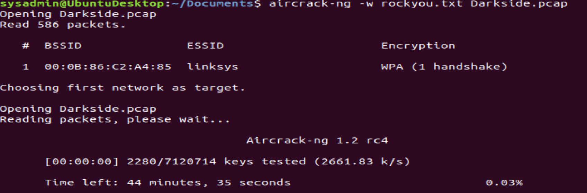

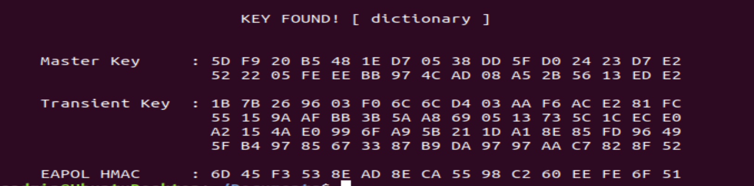

### **Mission 7**

As a thank you for saving the galaxy, the Resistance wants to send you a secret message!

Your Mission:

* View the DNS record from Mission #4.
* The Resistance provided you with a hidden message in the TXT record, with several steps to follow.
* Follow the steps from the TXT record.  
  + **Note**: A backup option is provided in the TXT record (as a website) in case the main telnet site is unavailable
* Take a screen shot of the results.

